PRACTICAL LOGBOOK
BIT3208: Advanced Web Design and Development
Practical Logbook

Student Details
Student Name | ELVIS WAMBUGU
Admission Number | BSCCS/2024/54678
Course / Class | COMP SCI 10AM CLASS
Unit Code | BIT3208
Unit Name | ADVANCED WEB DESIGN AND DEVELOPMENT
Lecturer Name | MR NYORO MICHAEL
Semester / Year | SEMESTER 2 YEAR 3

Project Details
Project Title
Technologies Used | e.g. PHP + MySQL
GitHub / Portfolio Link | https://github.com/elvis-cdev

Table of Contents
(Right-click → Update Field to refresh page numbers)
Table of Contents 2
Week 1: Local Environment Setup 3
Week 2: Wireframes and GUI Design 5
Week 3: JavaScript and PHP Basics 7
Week 4: User Authentication System 9
Week 5: Database Design and Integration 11
Week 6: CRUD Operations 13
Week 7: Frontend Development 15
Week 8: Advanced Features 17
Week 9: System Testing and Debugging 19
Week 10: Deployment and Project Submission 21

Week 1: Local Environment Setup
Installation and Testing of Local Development Environment
Required Evidence
Fig 1: Installation of XAMPP

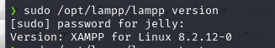

Fig 2: Apache and MySQL Running
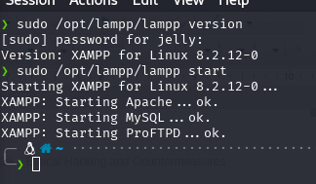

Fig 3: Localhost Test Page
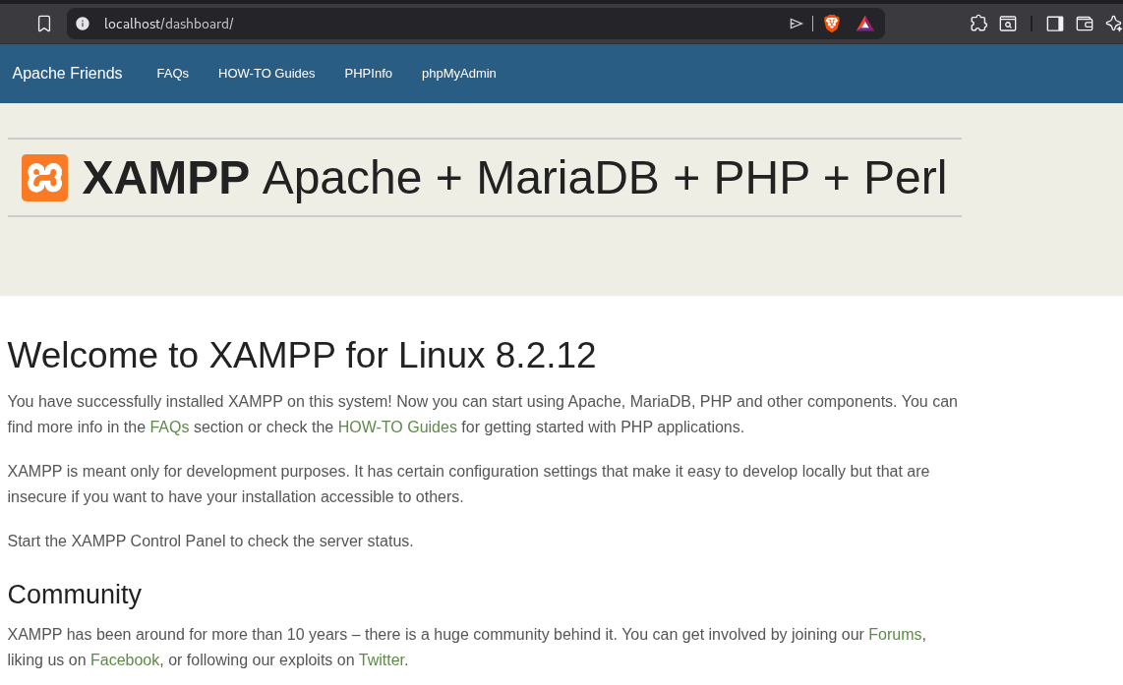
Fig 4: Hello World Test
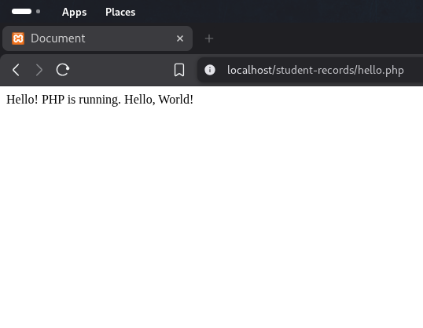
Fig 4: Hello World Test

Fig 5: Database Connection Test
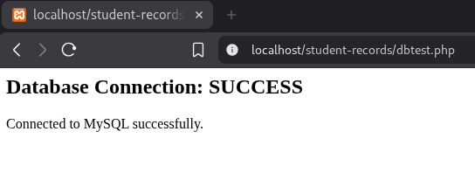

Student

Student Reflection
I began by installing XAMPP on Linux and setting up the development environment. I created the Students MIS database, built the folder structure, and wrote the first PHP files including the database connection string using PDO. This week gave me a solid foundation for the entire project. I used the database connection string.

Week 2: Wireframes and GUI Design
User Interface Planning and System Design
Required Evidence
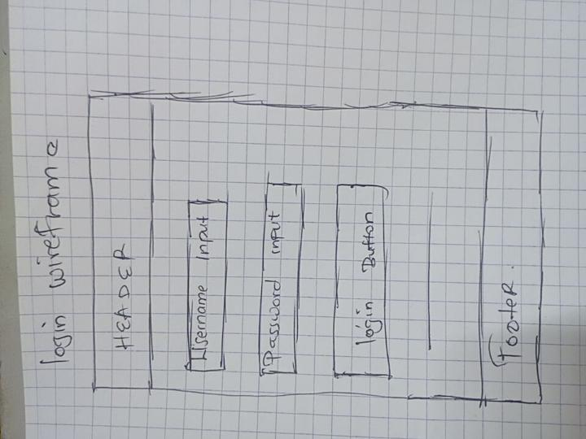
Fig 1: Hand-drawn Wireframe (Login/Homepage)

Fig 2: Dashboard Layout Design
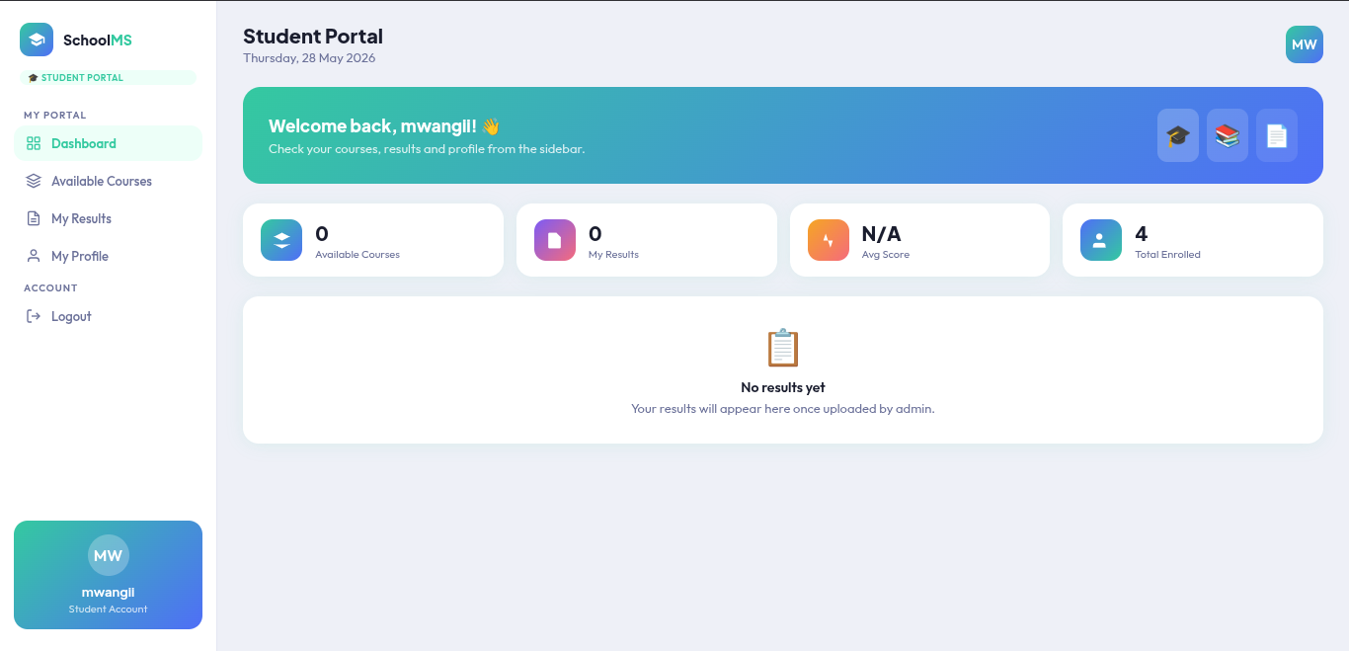
Fig 2: Dashboard Layout Design

Fig 3: Mobile View Mockup

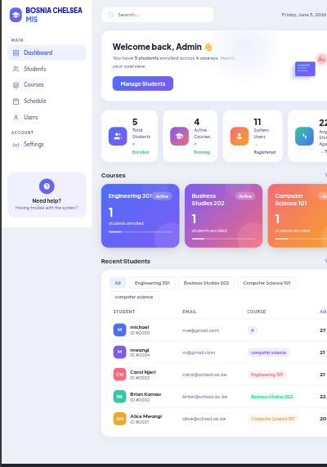

Fig 4: Color Theme and Navigation Structure

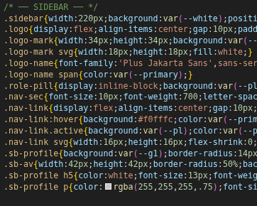

Fig 5: GUI Prototype in Figma/Canva/Draw.io
[ Insert Screenshot Here ]
Fig 5: GUI Prototype in Figma/Canva/Draw.io

My Reflection Week 2
I designed hand-drawn wireframes for the login, dashboard, homepage, and student records pages. I selected a navy and gold color scheme and planned the navigation layout. I also created a digital GUI prototype showing mobile responsiveness, color themes, and structured navigation flow for the system.

Week 3: JavaScript and PHP Basics
Frontend Interaction and Backend Foundations
Required Evidence
Fig 1: JavaScript Form Validation

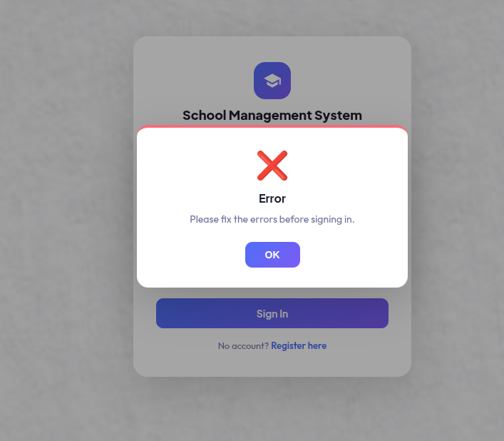

Fig 2: Password Strength Checker

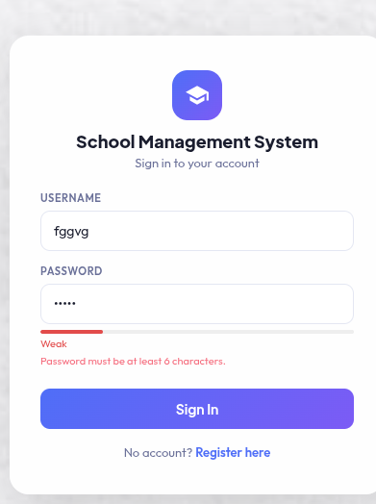

Fig 3: PHP Syntax Practice
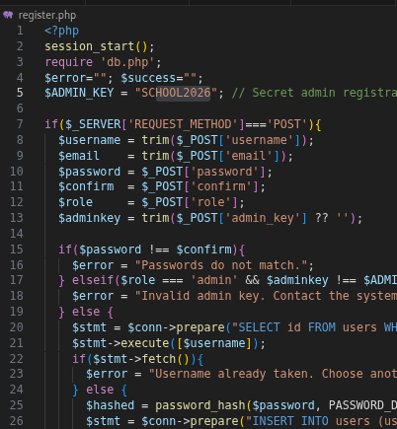

Fig 4: Database Connection Script
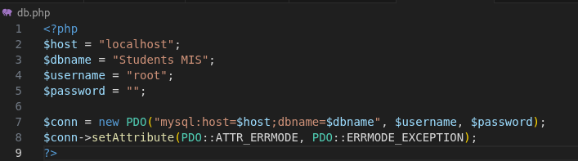
Fig 4: Database Connection Script

Fig 5: Dynamic User Input Handling
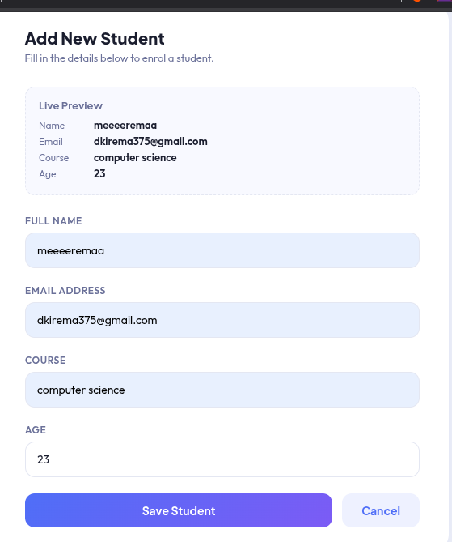
Fig 5: Dynamic User Input Handling

My reflection week 3
I practiced JavaScript by building form validation and handling user input dynamically. I also wrote basic PHP scripts to process form data server-side. Connecting the frontend to the backend helped me understand how data flows between the browser and the server before reaching the database.

Week 4: User Authentication System
Login, Registration and Session Management
Required Evidence
Fig 1: User Registration Form
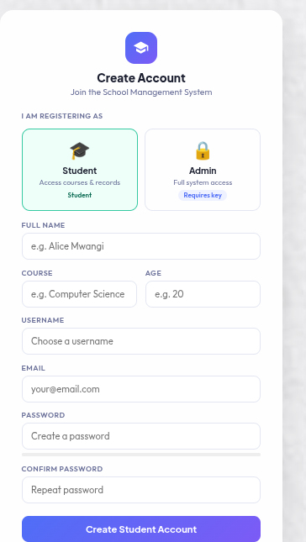

Fig 2: PHP Registration Script with Password Hashing
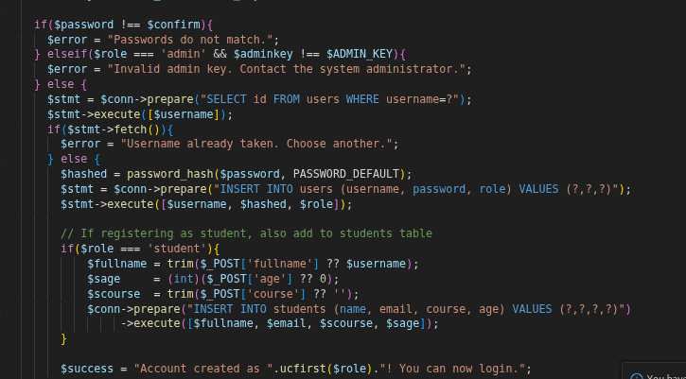

Fig 3: Login Form and Validation
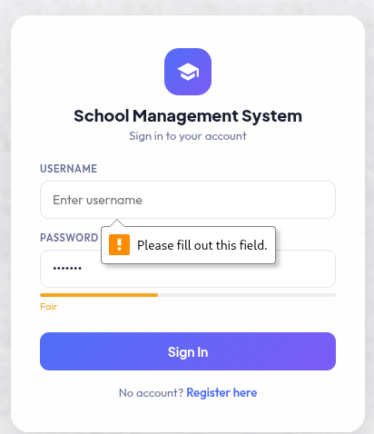

Fig 4: Session Management Code

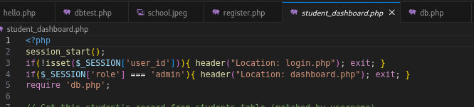

Fig 5: Successful Login and Dashboard Redirect
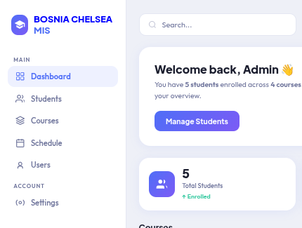

My reflection week 4
I practiced connecting PHP to MySQL using PDO with a proper connection string. I tested the connection and displayed a success message on screen. I also explored how prepared statements protect against SQL injection, and confirmed all four database tables were accessible and returning data correctly.

Week 5: Database Design and Integration
Entity Relationships and Data Management
Required Evidence
Fig 1: Entity Relationship Diagram (ERD)
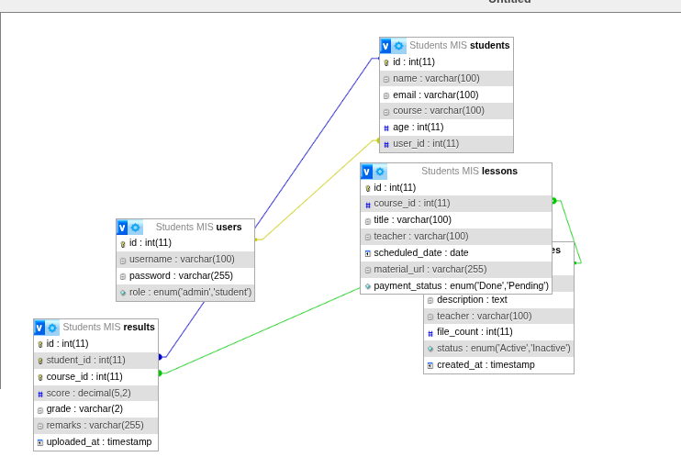

Fig 2: Database Tables in phpMyAdmin

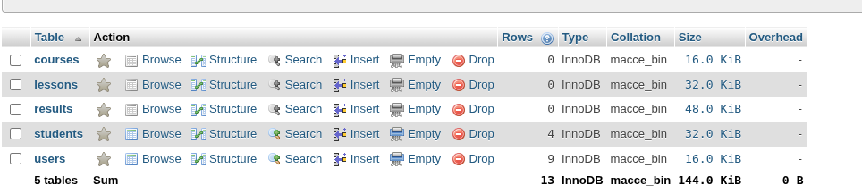

Fig 3: SQL CREATE TABLE Statements

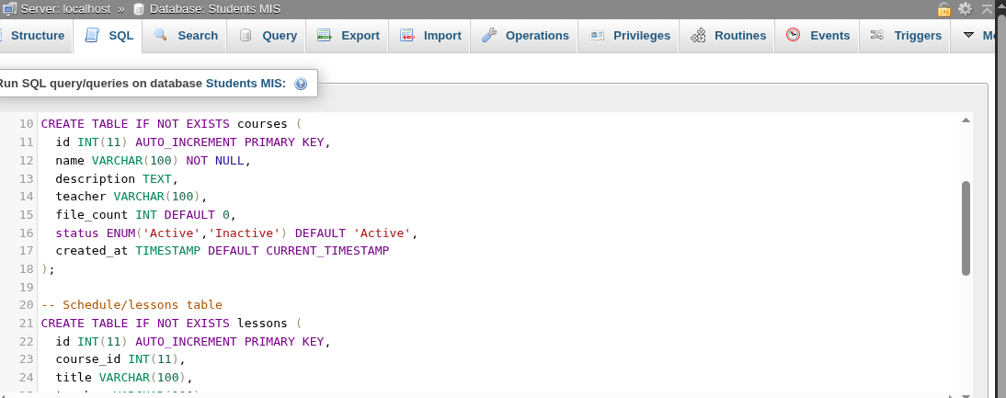
Fig 4: Data Insertion Script
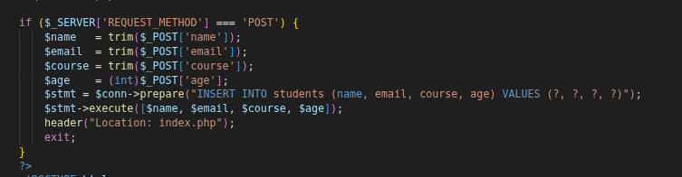

Fig 5: Query Result / Data Retrieval
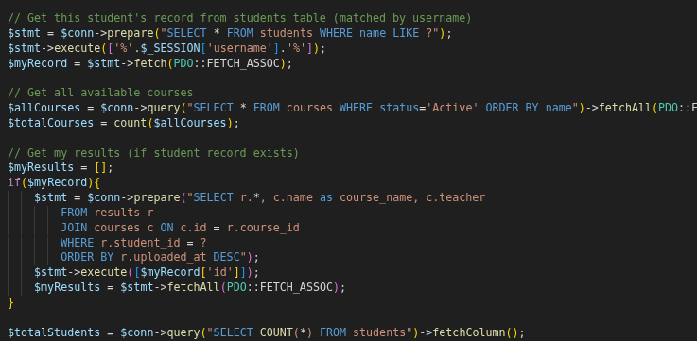
My Reflection week 5
I designed the database structure for the Students MIS, creating tables for students, courses, users, and enrollments with proper relationships. I drew an ERD to map the connections between entities and wrote SQL CREATE TABLE statements with primary and foreign keys. I tested data insertion and retrieval using php tech.

Week 6: CRUD Operations
Create, Read, Update and Delete Functionality
Required Evidence
Fig 1: Create / Add Record Form
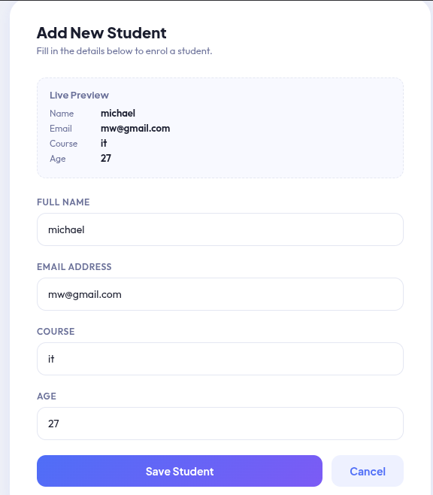

Fig 2: Database Record Listing
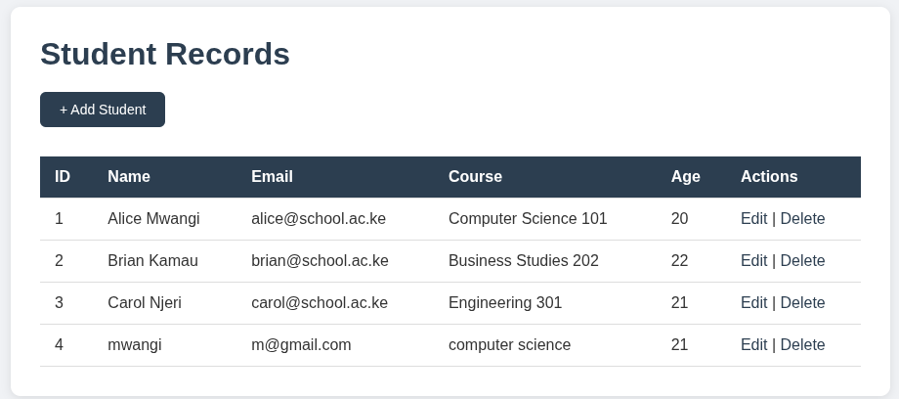

Fig 3: Edit / Update Form and Script

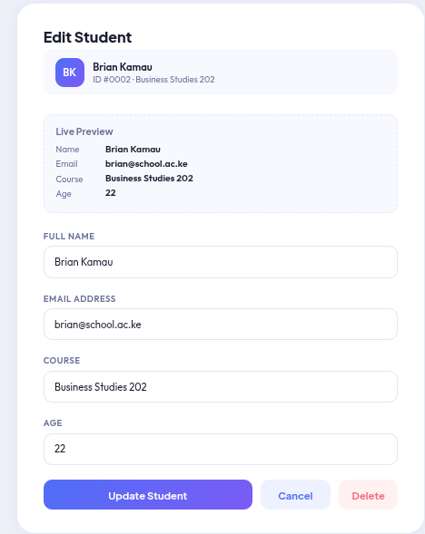

Fig 4: Delete Confirmation and Script
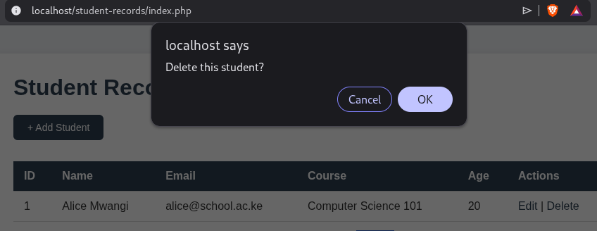

Fig 5: Database Changes Verified in phpMyAdmin
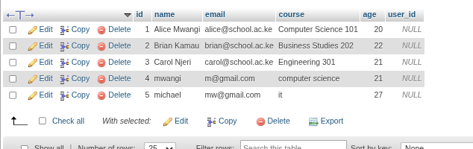

My Reflection week 6
I implemented full CRUD(create,read,update,delete)functionality for student records using PHP and MySQL. The add form inserts new records, the edit form fills existing data for updates, and delete triggers a confirmation before removing. All operations were tested and verified in phpMyAdmin confirming the database updated correctly.

Week 7: Frontend Development
Responsive Design and User Interface Refinement
Required Evidence
Fig 1: Responsive Navigation Bar
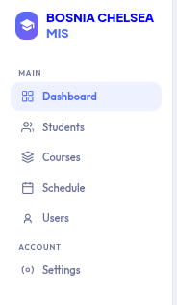

Fig 2: CSS Styling Applied to Dashboard
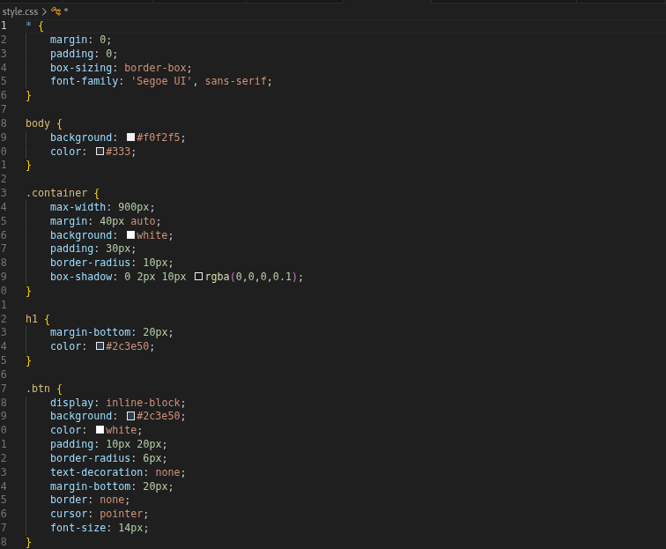

Fig 3: Mobile Responsive Layout (Browser DevTools)
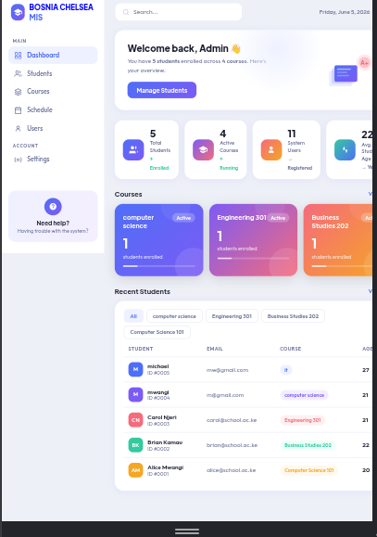

Fig 4: Form Styling and UX Improvements
[ Insert Screenshot Here ]
Fig 4: Form Styling and UX Improvements

Fig 5: Desktop vs Mobile Comparison
[ Insert Screenshot Here ]
Fig 5: Desktop vs Mobile Comparison

Student Reflection
Student Reflection (Maximum 100 words)

Week 8: Advanced Features
Extended Functionality and System Enhancements
Required Evidence
Fig 1: Search / Filter / Pagination Feature
[ Insert Screenshot Here ]
Fig 1: Search / Filter / Pagination Feature

Fig 2: API Request and Response
[ Insert Screenshot Here ]
Fig 2: API Request and Response

Fig 3: Data Display from External Source
[ Insert Screenshot Here ]
Fig 3: Data Display from External Source

Fig 4: Error Handling Implementation
[ Insert Screenshot Here ]
Fig 4: Error Handling Implementation

Fig 5: Feature Testing Result
[ Insert Screenshot Here ]
Fig 5: Feature Testing Result

Student Reflection
Student Reflection (Maximum 100 words)

Week 9: System Testing and Debugging
Quality Assurance and Bug Fixes
Required Evidence
Fig 1: Test Cases Table / Document
[ Insert Screenshot Here ]
Fig 1: Test Cases Table / Document

Fig 2: Bug Identified – Error Screenshot
[ Insert Screenshot Here ]
Fig 2: Bug Identified – Error Screenshot

Fig 3: Code Fix Applied
[ Insert Screenshot Here ]
Fig 3: Code Fix Applied

Fig 4: Successful Test After Fix
[ Insert Screenshot Here ]
Fig 4: Successful Test After Fix

Fig 5: Browser Console – No Errors
[ Insert Screenshot Here ]
Fig 5: Browser Console – No Errors

Student Reflection
Student Reflection (Maximum 100 words)

Week 10: Deployment and Project Submission
Hosting, Version Control and Final Portfolio
Required Evidence
Fig 1: GitHub Repository – Commit History
Fig 1: GitHub Repository – Commit History

Fig 2: Deployment Configuration (Netlify/Vercel/Render)
[ Insert Screenshot Here ]
Fig 2: Deployment Configuration (Netlify/Vercel/Render)

Fig 3: Live Hosted Website Screenshot
[ Insert Screenshot Here ]
Fig 3: Live Hosted Website Screenshot

Fig 4: Final Project Dashboard / Homepage
[ Insert Screenshot Here ]
Fig 4: Final Project Dashboard / Homepage

Fig 5: README File in Repository
[ Insert Screenshot Here ]
Fig 5: README File in Repository

Student Reflection
Student Reflection (Maximum 100 words)

